AMAZON

Roberto Chauca

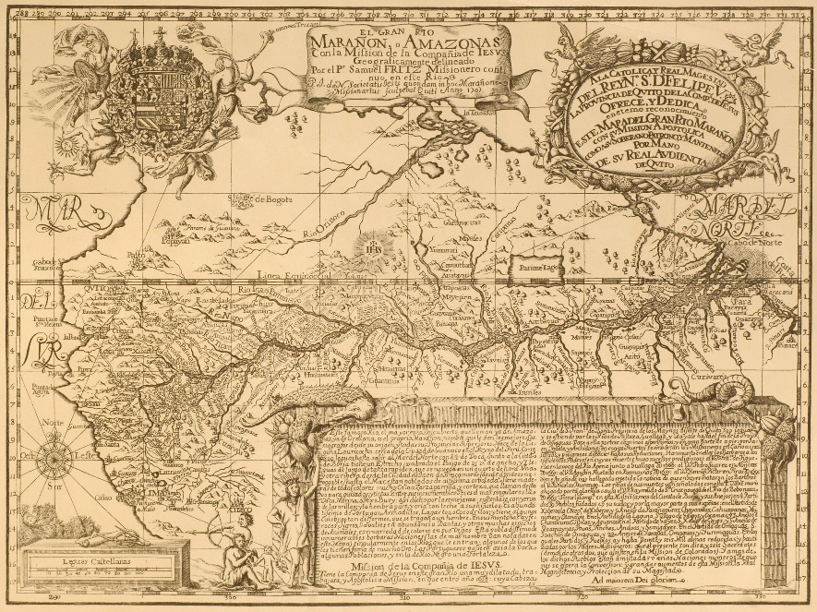

Figure 1. Samuel Fritz, El Gran Rio Marañon, o Amazonas con la Mision de la Compañía de Jesus, 1707. Archivo del Ministerio de Relaciones Exteriores de Ecuador.

Our current vision of the Amazon River was pioneered by Samuel Fritz. A member of the Society of Jesus, he left his native Bohemia –today’s Czechia— for South America in 1686 and remained in the Jesuit Province of Quito, today’s Ecuador, until 1725. Fritz is perhaps best known for authoring a map of the Amazon River, engraved in Quito in 1707 (Figure 1). To understand the pioneering role that Fritz’s 1707 Quito map played in the establishment of our current vision of the river’s course, we must review the earlier views of cartographers, geographers and chroniclers, most of whom were based in Europe.

In his *Descripción de las Indias Occidentales* (Madrid, 1601), the Chief Chronicler of the Indies, Antonio de Herrera y Tordesillas noted that the headwaters of the Rio de la Plata consisted of many rivers running south from the great Lake of Xarayes, located in the South American interior. Interestingly, this lake received in addition fluvial waters from the eastern flanks of the Andes, mainly from the regions of Charcas and Cuzco, which were in turn tributaries of the Amazon river. These latter rivers did not run south but north, however, creating the impression that the River Plate and the Amazon were connected through the headwaters at Lake Xarayes. More than a mere impression, this fluvial connection depicted the Amazon as running in a longitudinal manner. This north-south orientation was graphically represented in several seventeenth-century maps by some of the most recognized cartographers in Europe. This orientation is seen, for instance, in Joannes de Laet’s ‘Paraguay o Provincia de Rio de la Plata’ (Leiden, 1633), Jan Jansson’s ‘Americae Pars Meridionalis’ (Amsterdam, 1650) (Figure 2), Nicolas Sanson d’Abbeville’s ‘Amerique Meridionale’ (Paris, 1650) (Figure 3), and Willem Bleau’s ‘Americae Nova Tabula’ (Amsterdam, 1665).

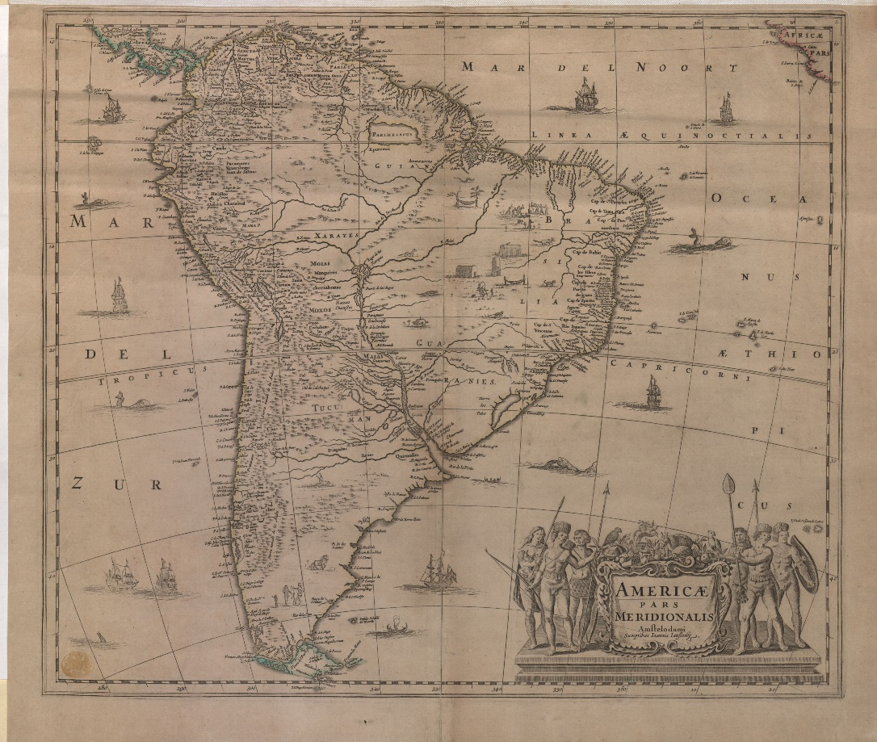

Figure 2. Jan Jansson, Americae pars Meridionale, 1647? Wikimedia Commons, public domain.

The cartographic delineation of the Amazon River in a longitudinal or north-south orientation was the foundation of what we know today as the ‘Brazil-as-an-island’ concept. In this view, the large Lake of Xarayes, located in the middle of the South American continent, served as a point of connection with the Rio de la Plata, which flowed southwards, and the Amazon, which ran north. Brazil came to be cartographically represented as a *de facto* island, separated from the rest of the continent by these two rivers conjoined by the lake. More problematic, in geopolitical terms, was the convergence of this riverine, longitudinal delineation with the line dividing the Iberian Empires according to the 1494 Treaty of Tordesillas. The implication was that both Crowns could exert dominion along the entire Amazon and River Plate, since the rivers constituted the very line dividing the Portuguese and Spanish realms in South America. As a

result, the maps of South America produced by some of the most renowned seventeenth-century cartographers had to be contested from the Spanish side, since this riverine delineation gave practically a free pass to Portuguese and other potential Atlantic powers, to navigate upriver toward the sources of the Amazon and River Plate to the Viceroyalty of Peru, including its most precious resource, namely, the silver mines of Potosi.

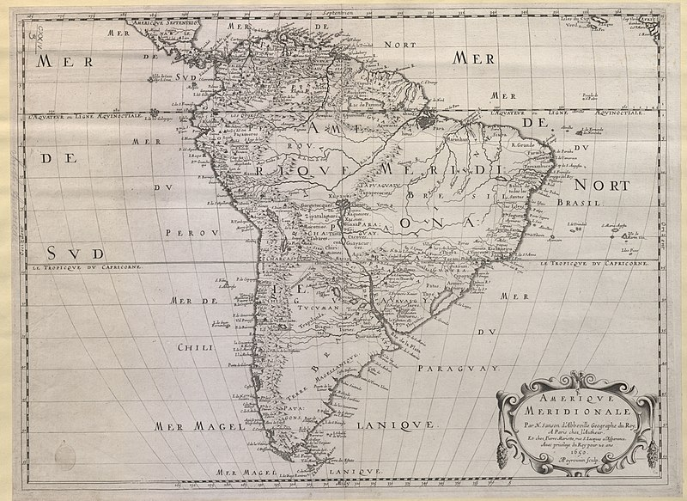

Figure 3. Nicolas Sanson d’Abbeville, Amerique Meridionale, 1650. Source: Wikimedia Commons, public domain.

The most important agents of Spanish Empire in Amazonian South America at the time were the friars of the Society of Jesus. Jesuit missionary presence became solidified here after the expedition led by the Portuguese Captain Pedro Texeira in 1637. One of the members of the expedition was Cristobal de Acuña, former director of the Jesuit College of Cuenca in the Audiencia of Quito. After the conclusion of Texeira’s expedition, Acuña continued his journey across the Atlantic, presenting a report to the King of Spain and the Indies, subsequently published as *Nuevo descubrimiento del gran rio de las Amazonas* (Madrid, 1641). This account became an immediate best-seller. By the end of the seventeenth century it had been translated into French and English and reedited in Spanish. This success made Acuña one of the leading authorities in Amazonian affairs in terms of knowledge about its geographical characteristics, indigenous inhabitants, and natural resources.

Although Acuña’s account did not include maps, there is a contemporaneous manuscript chart of the Amazon that expresses his description of the river (Figure 4). This chart was included at the end of the 1639 anonymous manuscript, ‘Descubrimiento del Rio de las Amazonas y sus dilatadas provincias,’ held at the National Library of Spain in Madrid. The manuscript, whose authorship is credited either to Alonso de Rojas, then director of the Jesuit College of Quito, or Acuña himself, describes Teixeira’s expedition as well. It portrays the Amazon with a peculiar longitudinal orientation, with the city of Quito at the top of the map as the headwaters of the river. This map is focused on the course of the Amazon, depicting the route followed by the Teixeira expedition that connected the city of Quito with the cities of Belém and São Luis. Though this map does not make any connection between the hydrographic basins of the Amazon and the Rio de la Plata, its vertical orientation resembled the riverine delineation characteristic of the ‘Brazil-as-an-island’ maps made in Europe. The chart lent support to the development and advancement of Portuguese Jesuit missionary activity along the course of the Amazon. Such was also the case of Simão de Vasconcellos and his ‘Chronica da Companhia de Jesu do Estado do Brasil’ (Lisbon, 1663). Vasconcellos argued that the Plate and Amazon rivers were like two silver keys that locked up the land of Brazil or, more graphically, two giants defending and demarcating the line dividing the Portuguese and Spanish realms in South America. The implications of this description were that there was not a Spanish or a Portuguese Amazon but rather a joint and shared jurisdiction over the river.

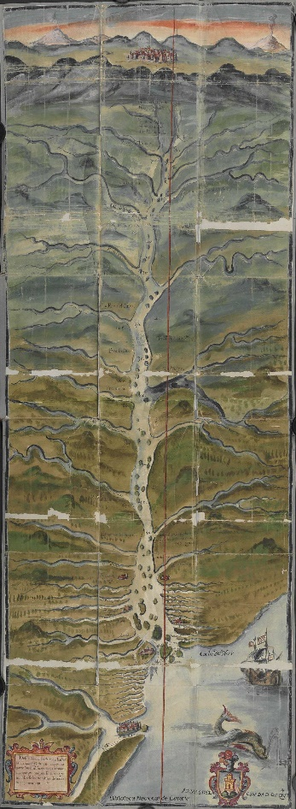

Figure 4. Anonymous. [Mapa del río Amazonas y su cuenca]. In: [Martín de Saavedra], [Descubrimiento del Río Amazonas y sus dilatadas provincias], [1639]. Biblioteca Nacional de España, MSS/5859 (H. 32).

A few decades later, a more decisive cartographic response from the Spanish side reversed the longitudinal depiction of the Amazon to establish once and for all the now conventional latitudinal vision of the river. As an object of knowledge, scholars have praised Fritz’s map for its detailed ethnographic and scientific information, and, interestingly, as one of the silenced sources of the Frenchman Charles-Marie de la Condamine, head of the scientific exploration to the Amazon River and author of a map and travel account of the region, ‘Relation abrégée d'un voyage fait dans l'intérieur del'Amérique méridionale’ (Paris, 1745). An unattended aspect of Fritz’s map, however, was its objective to amend European and, specifically, Portuguese longitudinal representations of the Amazon with a view that privileged its Peruvian headwaters.

Unlike Acuña’s description and the ‘Brazil-as-an-island’ maps of South America, Fritz’s Amazon assumes a latitudinal or horizontal orientation. This representation, then in need of a stronger foundation, was reinforced by suggesting a new source for the river. At the beginning of the attached note included in the lower right hand corner of Fritz’s 1707 map, it is stated that: ‘This famous River, the greatest that has been discovered, that bears the name sometimes of Amazons, sometimes of Orellana, is properly the Marañon, a name that the majority of cosmographers give to it from its sources and all the provinces of its upper course. It springs from the lake Lauricocha close to the city of Guánuco of the Kingdom of Peru.’ This emphasis on the proper headwaters of the river may seem superfluous to present-day eyes but it was a decisive challenge to the conventional, longitudinal representation of the Amazon river. First, Fritz’s map took aim at Acuña’s ‘Nuevo descubrimiento.’ That account had located the headwaters of the river near the city of Quito. Second, and most important, Fritz’s map sought to debunk the notion that the river originated in Lake Xarayes, a geographical vision that was still held and defended by Portuguese authorities.

After a series of circumstances in the middle Amazonian missions under his observance, in 1689 Fritz navigated down the Amazon to seek shelter in the city of Belém. He returned to Quito in 1691. During these two years, he stayed at the local Portuguese Jesuit College of Pará, where he had the opportunity to discuss and chart the Iberian possessions along the Amazon with local officials, in particular the Governor of Pará, Antonio de Albuquerque. In these deliberations, Fritz defended his right to missionize in the middle Amazon by showing Albuquerque an early manuscript version of his 1707 engraved map. Meanwhile, the Governor deployed the ‘Brazil-as-an-island’ argument to defend the Portuguese right of possession over the Amazon by showing Fritz a world map made by Aloïs Conrad Pfeil, Jesuit cartographer and astronomer at the College of Pará.

This Spanish-Portuguese debate among Jesuits at Belem suggests that the longitudinal representation of the Amazon was problematic for the very existence of the Spanish Jesuit missions in the region. The issue persisted until 1702, when Fritz prepared a report complaining of Portuguese incursions into his middle Amazonian missions. Against the Lusitanian arguments, Fritz noted that the Amazon River ‘from its mouth westward, turns neither northward nor southward completely, instead it always runs following the equinoctial line.’ In 1707, when Fritz, now Superior Father of the Jesuit missions of the Province of Quito, had the necessary resources to have his map of the river engraved, the ‘equinoctial’ orientation of the Amazon river would be famously established. The convention continues to shape our view of the river today.

FURTHER READING

André Ferrand de Almeida. ‘Samuel Fritz and the Mapping of the Amazon.’ *Imago*

*Mundi* 55 (2003):113-119; and ‘Samuel Fritz Revisited: The Maps of the Amazon and their Circulation in Europe,’ in *La cartografia europea tra Primo Rinascimento e fine dell’Illuminismo*, eds., Diogo Ramada Curto, Angelo Cattaneo, and André Ferrand de Almeida, 133-153. Florence: Leo S. Olschki, 2003.

Hugo Burgos, *La Crónica Prohibida: Cristóbal de Acuña en el Amazonas*. Quito: FONSAL, 2005.

Camila Dias, “Jesuit Maps and Political Discourse: The Amazon River of Father Samuel Fritz,” *The Americas* 69:1 (2012): 95-116.

Carmen Fernández-Salvador, ‘Jesuit Missionary Work in the Imperial Frontier: Mapping the Amazon in Seventeenth-Century Quito.’ In *Religious Transformations in the Early Modern Americas*, eds., Stephanie Kirk and Sarah Rivett. Philadelphia: University of Pennsylvania Press, 2014, 205-227.

Samuel Fritz, S.I. *Journal of the Travels and Labours of Father Samuel Fritz in the River of the Amazons between 1686 and 1723*, translated and edited by George Edmunson. London: Hakluyt Society, 1922.

Protasio Langer. ‘Cartas geográficas edificantes: O imaginário da conversão dos povos indígenas nos mapas dos jesuítas Heinrich Scherer e Samuel Fritz.’ In *Conversão dos cativos: Povos indígenas e missão jesuítica*, eds. Paulo Suess et al. São Bernardo do Campo: Nhanduti, 2009, 79-90.

Octavio Latorre. *Los mapas del Amazonas y el desarrollo de la cartografía ecuatoriana en el siglo XVIII*. Guayaquil: Museos del Banco Central del Ecuador, 1988.

Iván Lucero S.I. ‘La cartografía de la antigua provincia de Quito de la Compañía de Jesús.’ S.T.L. thesis, Weston Jesuit School of Theology, 2004.

Neil Safier. *Measuring the New World: Enlightenment Science and South America*. Chicago, IL: University of Chicago Press, 2008.